Child protection information sharing system
The Child Protection - Information Sharing (CP-IS) service is a national system (across England) that securely links health and social care records to help protect children who:
- Are looked after by local authorities.
- Are subject to a child protection plan (including unborn child protection plans).
- Have been in either category within the previous 12 months
It enables health professionals to access key safeguarding information when a child presents at a healthcare setting, especially when they are outside their home local authority area.
In England, since 2014, the Child Protection Information Sharing System (CP-IS) has been sharing information between Local Authorities (LAs), unscheduled settings, and ambulance services about unborn babies & children who have a child protection plan and children who are looked after. This information sharing is intended to enable frontline staff who are working with children at risk of abuse or neglect to make well-informed assessments, identify emerging problems, and streamline interagency working to support the children and their families when and where they need it.
CP-IS is currently used across the following unscheduled healthcare settings:

- Emergency Departments (NHS Trusts)
- Minor Injury Units (NHS Trusts)
- Walk in Centres (CCGs/Primary Care)
- Urgent Care Centres/Urgent Treatment Centres
- GP Out of Hours only

The information CP-IS provides comes from and is managed and updated by Local Authorities (Councils) across England with the use of the child’s or mother’s NHS number. It does not include information from health or educational systems such as GP practices, schools, or health visitors (HVs), who continue to use Summary Care Records (SCRs) or the Primary Care Records to access health information.

As part of the NHS Long-Term Plan, it is now a target to make CP-IS available NHS-wide in England. So, the GP in hours service via the National Care Records Service, CP-IS data will be available and used 2 by December 2025.
This is to support decision-making processes undertaken by front-line NHS health practitioners, CP-IS will provide a limited amount of child protection indicator information (NHS Number, Type, start and end date of any child protection plan a child is on, name and contact details of the responsible LA, and an access history [including date and time] of the previous twenty-five visits to unscheduled care setting) about children at risk of abuse or neglect.

CP-IS does NOT SHARE:
- The child’s full social care file.
- The category of the CPP.
- Details of the child’s parents or carers.
- The reason the child has previously presented for care.
- Medical information.

While CP-IS will only be accessible to practitioners with the correct permissions, all our staff are responsible for ensuring they are aware of and understand this process.

How does CP-IS work

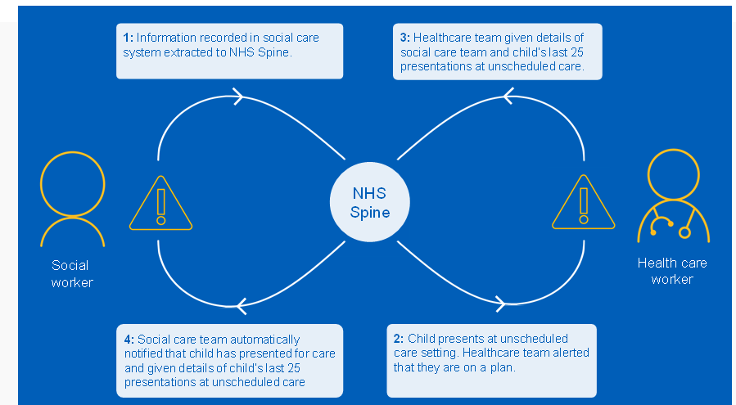

Benefits of CP-IS

- Early Intervention – Acting to prevent and or reduce future harm happening to children - With instant access to CP-IS information, communication with the appropriate Social Worker can occur quickly, leading to a better outcome for the child.

- Because the Social Worker is notified immediately if a child in their care has presented at an unscheduled care setting, they are better placed to assess whether any intervention is needed to achieve a good outcome for the child.

- Improved safety and care – Doing the best when children need help - Because health practitioners (in unscheduled and now scheduled care settings) can see CP-IS information about a child anywhere in England, they will be better equipped to make the right decision about that child’s care.

- Increased workforce efficiency and effectiveness – Doing the most for children with the resources we have - Because CP-IS automatically sends information to the NHS Spine daily, it is always up to date.

