BRIMINGTON SURGERY
PATIENT NOT ORDINARILY RESIDENT IN THE UK
Anybody in England can register with a GP practice and receive free medical care from that practice.
However, if you are not ‘ordinarily resident’ in the UK you may have to pay for NHS treatment outside of the GP practice. Being ordinarily resident broadly means living lawfully in the UK on a properly settled basis for the time being. In most cases, nationals, of countries outside the European Economic Area must also have the status of ‘indefinite leave to remain’ in the UK.

Some services, such as diagnostic tests of suspected infectious diseases and any treatment of those diseases are free of charge to all people, while some groups who are not ordinarily resident here are exempt from all treatment charges.

You may be asked to provide proof of entitlement in order to receive free NHS treatment outside of the GP practice, otherwise you may be charged for your treatment. Even if you have to pay for a service, you will always be provided with any immediately necessary or urgent treatment, regardless of advance payment.

The information you give on this form will be used to assist in identifying your chargeable status, and may be shared, including with NHS secondary care organisations (e.g. hospitals) and NHS Digital for the purposes of validation, invoicing and cost recovery. You may be contacted on behalf of the NHS to confirm any details you have provided.

NHS Number__________________________ Date of birth ____________

Title: Mr Mrs Miss Ms Other________________ Sex: M / F

First Name_________________________ Surname______________________________________

Previous Surname/s_____________________

Town & County of birth_____________________________________________________________

Address __________________________________________________________________________

________________________________________________ Postcode___________________________

Home phone ________________________ Mobile phone ________________________________

Please tick as applicable:

- I understand that I may need to pay for NHS treatment outside of the GP practice

- I understand I have a valid exemption from paying for NHS treatment outside of the GP practice. This includes for example, an EHIC, or payment of the Immigration Health Charge (“the Surcharge”), when accompanied by a valid visa. I can provide documents to support this when requested.

- I do not know my chargeable status

I declare that the information I give on this form is correct and complete. I understand that if it is not correct, appropriate action may be taken against me.

A parent/guardian should complete the form on behalf of a child under 16.
Signed |  | Date
Print name |  | Relationship to patient
On behalf of

Complete this section if you live in another EEA country, or have moved to the UK to study or retire, or if you live in the UK but work in another EEA member state. Do not complete this section if you have EHIC issued by the UK.
NON-UK EUROPEAN INSURANCE CARD (EHIC), PROVISIONAL REPLACEMENT CERTIFICATE (PRC) DETAILS AND S1 FORMS
Do you have a non-UK EHIC OR PRC? | YES NO | If yes, please enter details from your EHIC or PRC below
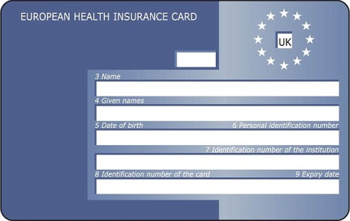  If you are visiting from another EEA country and do not hold a current EHIC (or Provisional Replacement Certificate (PRC))S1, you may be billed for the cost of any treatment received outside of the GP practice, including at a hospital. | Country code 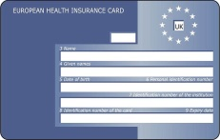
 | 3. Name
 | 4. Given Names
 | 5. Date of birth | DD MM YY
 | 6. Personal Identification Number
 | 7. Identification number of the institution
 | 8. Identification number of the card
 | Expiry Date | DD MM YY
PRCV Validity period (a) From | DD MM YY | (b) To | DD MM YY
Please tick if you have an S1 (e.g. you are retiring to the UK or you have been posted here by your employer for work or if you live in the UK but work in another EEA member state). Please give your S1 form to the practice staff.
How will your EHIC/PRC/S1 data be used? By using your EHIC or PRC for NHS treatment costs your EHIC or PRC data and GP appointment data will be shared with NHS secondary care (hospitals) and NHS Digital solely for the purposes of cost recovery. Your clinical data will not be shared in the cost recovery process.
Your EHIC, PRC, or S1 information will be shared with The Department for Work and Pensions for the purposes of recovering your NHS costs from your home country.

